MARINA ENGLISH HIGH SCHOOL IS A TOBACCO FREE EDUCATIONAL INSTITUTION.
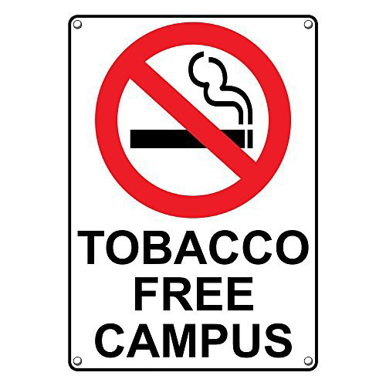
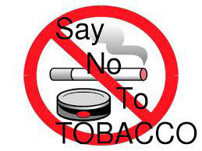

Offence is punishable under section 4 of the COPTA ACT.

